OuterJoin

1) Display the last name and the party description of each individual. If there is not a party associated with the individual then display “no party”
select lname, nvl2(mendoza_candidate.partyid, partydesc, 'no party') from mendoza_candidate left outter join on mendoza_candidate.partyid = mendoza_party.partyid;

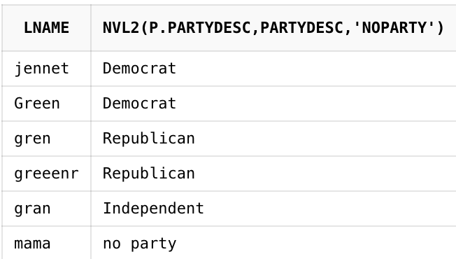
2) Display the last name and the party description of each individual. If there is a party that does not have any individuals associated with it, then display “No one”
select nvl(lname, 'no one'), partydesc from mendoza_candidate right outter join mendoza_party on mendoza_candidate.partyid = mendoza_party.partyid;

